ASSIGNMENT

**1)**

**Aim : Create a hand sanitizer spray bottle using blender**

**Methodology :**

1. Remove the cube light and camera added by default.
2. Add a mesh object – cylinder.
3. Extrude the cylinder by upper face and scale it to get the desired shape.
4. Extrude the upper portion again.
5. Go to object mode and shade smooth.
6. Take another mesh object – cylinder and rotate it.
7. Scale it and bring to the desired place.
8. Shade smooth.
9. Select the front part of it and go to particle settings.
10. 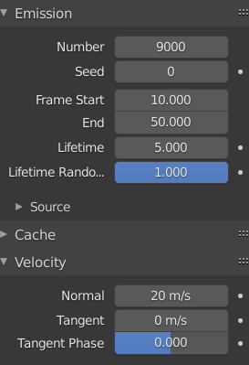
11. Set all the settings as shown here.
12. Take a sphere and shade smooth.
13. Add force to upper part of the spray.
14. In render option, set these –

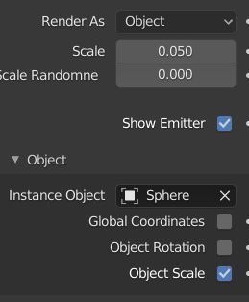

1. Apply color to the sanitizer and add material property.
2. Final output –

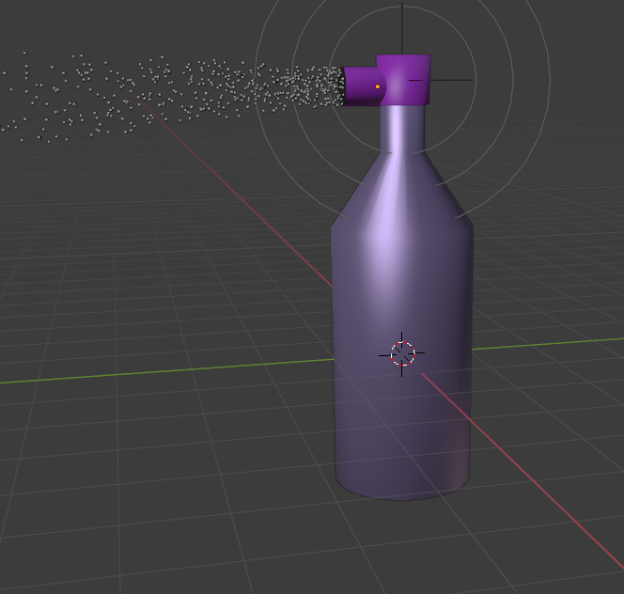

**2)**

**Aim : Logo of water bottle using gimp**

**Methodology :**

1. Take a plain white background.
2. Scale it.
3. Add two circle pictures – one big another small.
4. 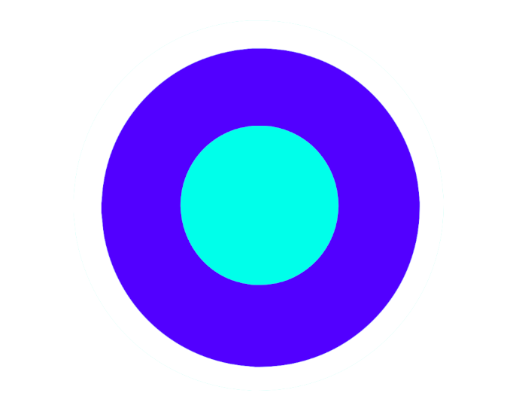
5. Add an image at the center of the circles.
6. Add text at the bottom.
7. Final output –

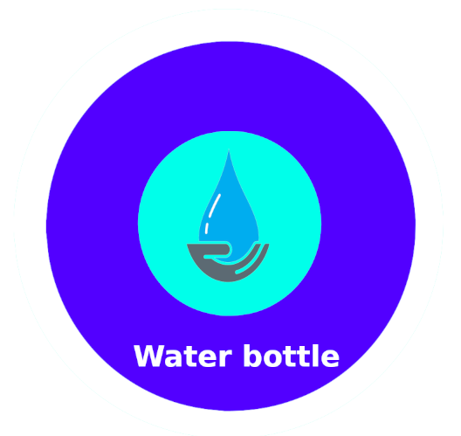

**Submitted by – Manushi Kapoor**

**Batch – CSE OSSOS B1**

**Sap id – 500062100**

**Roll no. – R100217037**